**Student Name: Basavraj Nagappa Jaliminche**

**Student Id: 88001419**

**PROGRAM: Reporting Systems and Database Development (1517)**

**Course Name: Relational Databases PROG 8590**

**Assignment No: 01**

**Assignment No: 01**

**Use SELECT command to get the desired results.**

**Q 1.Query full names and birthdates and sort them by their birthdates.**

**Query**: SELECT [firstName],[lastName],[birthdate]--To Display

FROM [dbo].[Person]--table name

ORDER BY [birthdate]--Sorting by Birthdate

**Description:**

* We have to use **Person** as a database.
* We have to display the columns so that we have to use **SELECT** clause. In that we need to select firstName , last Name and birthdate .
* To sort the names with birthday we have to use ORDER BY clause.
* After that we execute the query and display the results.

**On next page I have attached the screenshot of this query.**

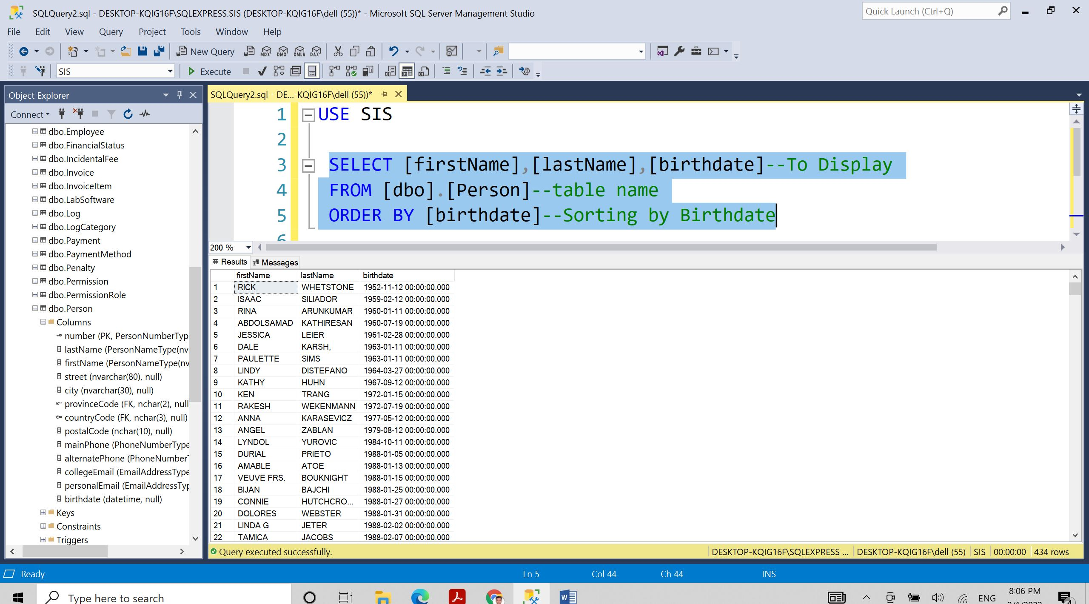

**Q 2. We need to get the postal code of the person with number: 7572381.**

**Query:**

SELECT [firstName],[lastName],[number],[postalCode] AS 'POSTAL CODE'

FROM [SIS].[dbo].[Person]

WHERE [number] = 7572381

**Description:**

* We have to select **Person** as a database.
* We have to display the columns so that we have to use **SELECT** clause.In that we have to select firstName,lastName,Number,postalCode.
* For the condition we have to use WHERE clause and put the condition as **number=7572381.**
* After that we execute the query and display the results.

**On next page I have attached the screenshot of this query.**

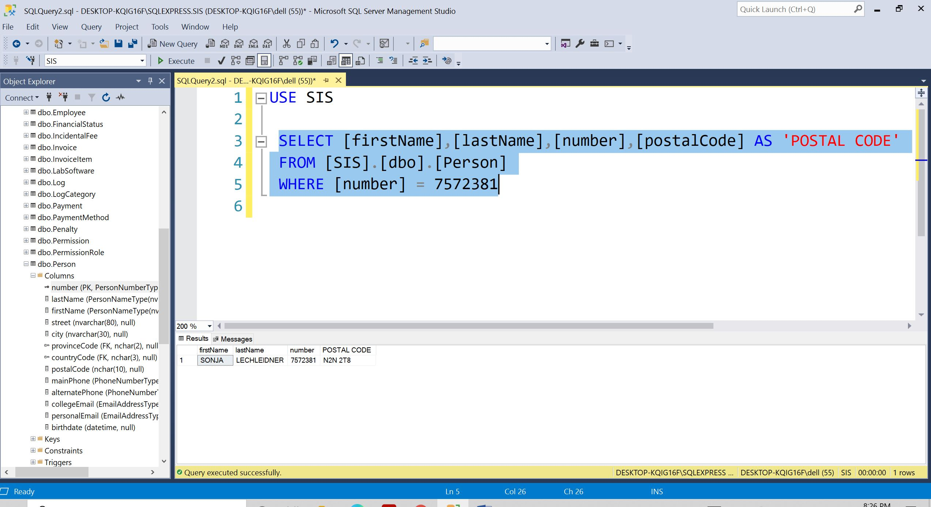

**Q 3. Write a query to show number, local city, and balance of the students with negative amount in their balance and sort them by their balances from highest value to the lowest. Change the Title to “Student ID” and “City”.**

**Query:**

SELECT [number] AS 'Student ID',[localCity] AS 'City',[balance]

FROM [dbo].[Student]

WHERE [balance]<0

ORDER BY [balance] DESC

**Description:**

* We have to select **Student** as a database.
* We have to display the columns so that we have to use **SELECT** clause.In that we have to select

Number as ‘Student ID’,localCity AS ‘City’,balance.

* For condition we have to use **WHERE** clause.Where we have to put condition as balance < 0.
* For sorting the results higher to lower we use **ORDER BY** clause and **DESC.**
* After that we execute the query and display the results.

**On next page I have attached the screenshot of this query.**

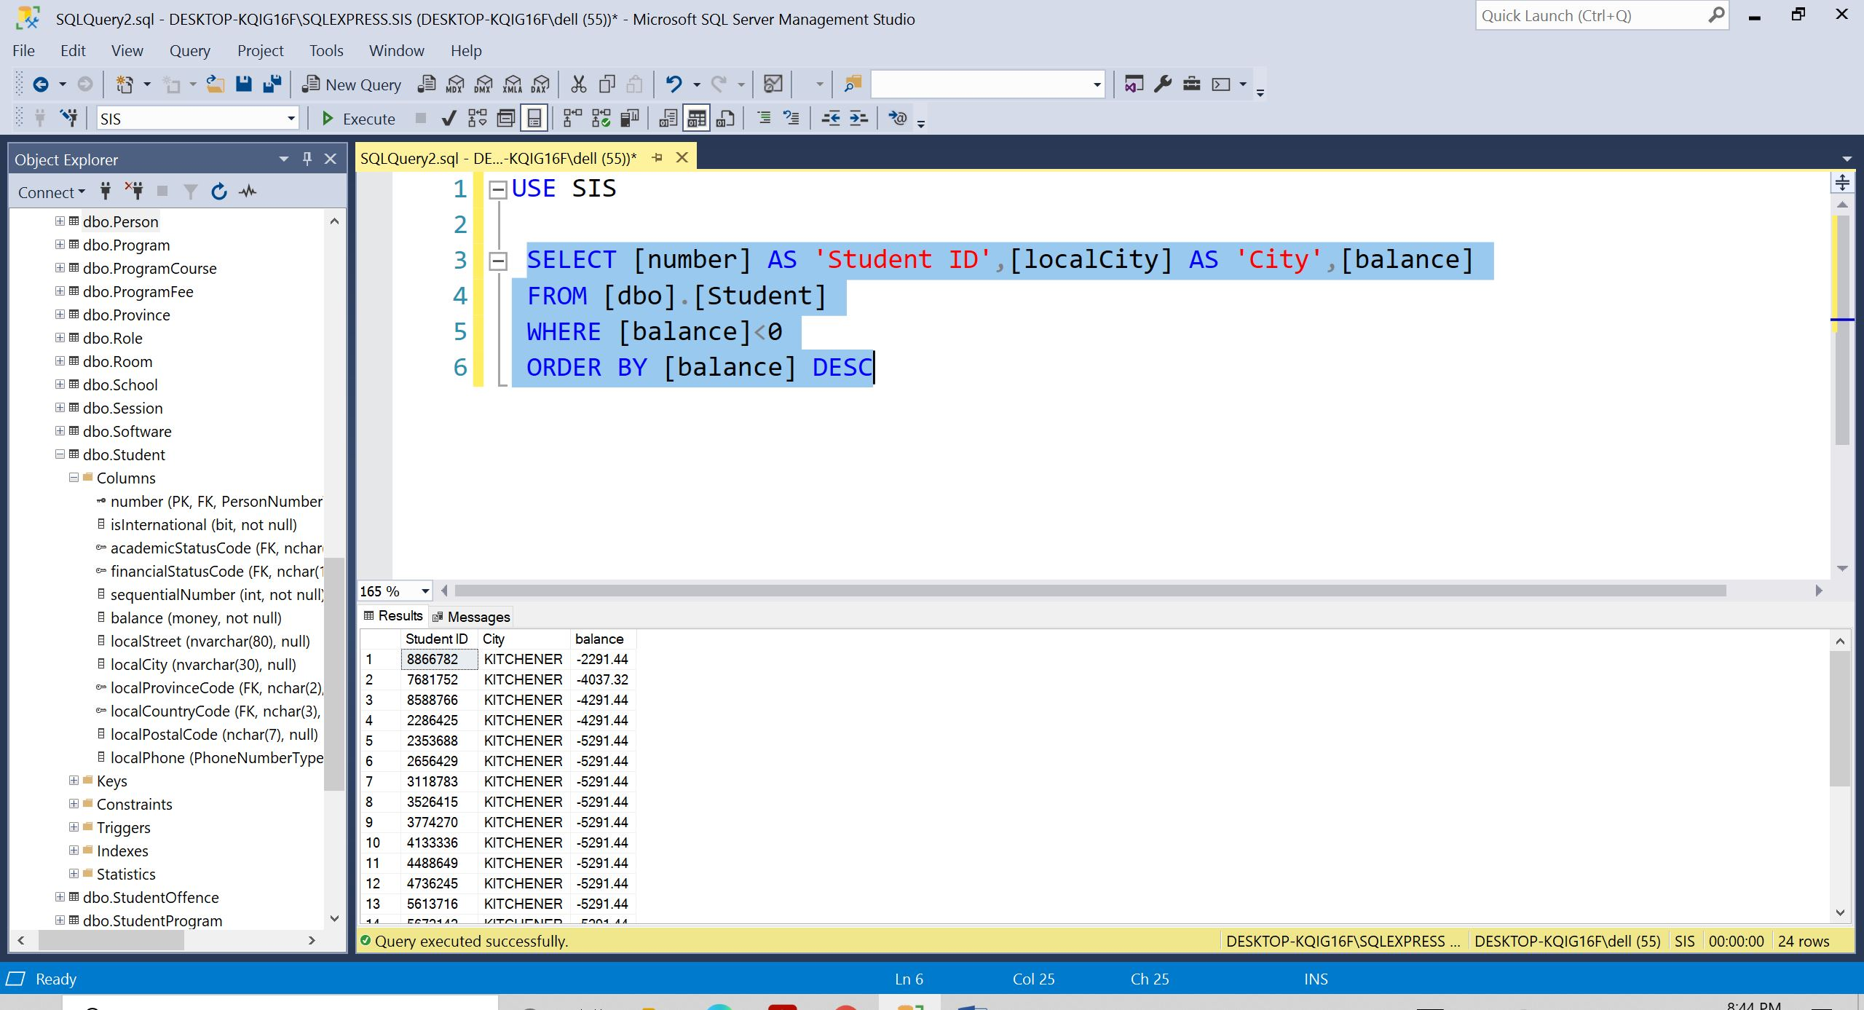

**Q 4. Write a query to show the first name, last name, alternate phone number, and country code of the persons who have a Null value in their alternate phone numbers and their country code is not ‘CAN’.**

**Query:**

SELECT [firstName],[lastName],[alternatePhone],[countryCode]

FROM [dbo].[Person]

WHERE [alternatePhone] IS NULL ---WHERE ALTERNATE PHONE NO IS NULL

AND [countryCode] != 'CAN'---WHERE COUNTRY CODE IS NOT EQUAL TO CAN

**Description:**

* We have to select **Person** as a database.
* We have to display the columns so that we have to use **SELECT** clause. In that we have to select firstName,lastName,alternatePhone,countryCode.
* For condition we have to use **WHERE** clause. Where we have to put condition as alternatePhone IS NULL AND countryCode not equal to (!=) ‘CAN’.
* After that we execute the query and display the results.

**On next page I have attached the screenshot of this query.**

